Configuration

The Settings of the VBOUT extension can be configured in **Stores -> Configuration -> VBOUT -> VBOUT** backend page.

**1. API Settings** tab



**Include jQuery Library** - this option allows include jQuery if Magento site not available jQuery

**2. API Settings** tab

In this tab, you can get your unique **API User Key** from VBOUT.

Go to [https://app.VBOUT.com/Settings](https://app.vbout.com/Settings) -> API Integrations to get API Key:

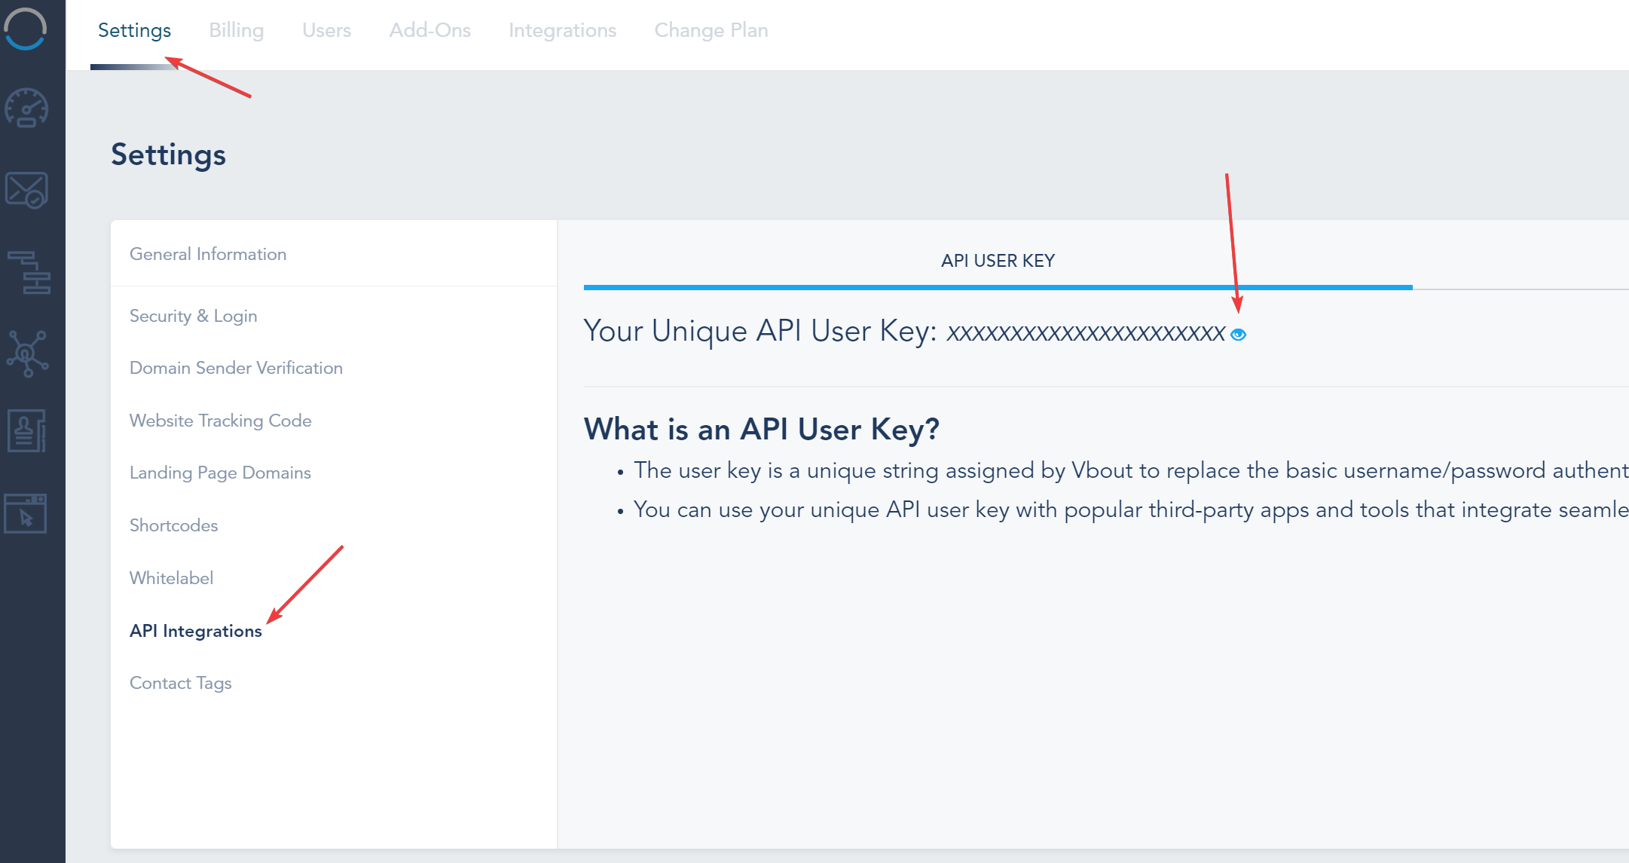

In **Integration Settings** tab, you can activate the data points you wish to sync between Magento and your VBOUT account. Choose ‘Yes’ to enable the options as below:

